**Dharmsinh Desai University, Nadiad**

**Department of Information Technology**

**DAIE, IT704**

**B.Tech. IT, Sem: VII**

**Experiment – 04-05 (Star Schema Diagram)**

**Submitted By**

**Roll No.: IT076**

**Name: DISHANT MODH**

**Aim: 1. Draw Star Schema diagram for Sales All Electronics Store. 2. Make Schema Table in Oracle Live.**

**3. Perform DMQL Query like Rollup, Drill down ..etc on it. Tools/Apparatus:** Oracle Live Online

**4.1) Write down SQL query for Dimension tables Item, Branch, Location and Time with proper syntax and primary key.**

1) Product Table

create table branch (

branch_id number not null,

branch_name varchar2(30) not null,

branch_manager varchar2(30) not null,

branch_city varchar2(30) not null,

primary key(branch_id) );

2)Branch Table

create table branch (

branch_id number not null,

branch_name varchar2(30) not null,

branch_manager varchar2(30) not null,

branch_city varchar2(30) not null,

primary key(branch_id) );

3) Location Table

create table location_data (

location_id number not null,

location_city varchar2(30) not null,

location_state varchar2(30) not null,

location_country varchar2(30) not null,

primary key(location_id)

);

4)Time Table

create table time_data (

time_id number not null,

time_ts timestamp with time zone not null,

time_date date not null,

primary key(time_id)

);

**Star Schema**

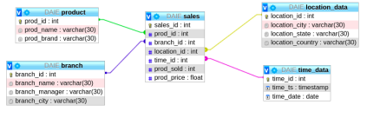

**4.2) Write down SQL query for Sales fact table using primary keys of all dimension tables as a foreign key.**

create table sales (

sales_id number not null,

prod_id number not null,

branch_id number not null,

location_id number not null,

time_id number not null,

prod_sold number not null,

prod_price float not null,

foreign key(prod_id) references product(prod_id),

foreign key(branch_id) references branch(branch_id), foreign key(location_id) references location_data(location_id), foreign key(time_id) references time_data(time_id), primary key(sales_id)

);

**4.3) Sample SQL query to Insert data in dimension tables.** 1) Product Data

insert into product values(1,'iPhone 13','Apple');

insert into product values(2,'9R','OnePlus');

insert into product values(3,'GT','Realme');

insert into product values(4,'Z Fold 3','Samsung');

insert into product values (5,'11 Ultra’, ‘MI');

2)Branch Data

insert into branch values(1,'iVenus','Deep Shah’, ‘Surat'); insert into branch values(2,'Pujara','Meet Patel’,’ Nadiad'); insert into branch values(3,'Phone Wale','Jay Desai’, ‘Ahmedabad'); insert into branch values(4,'Croma','Manan Shah’, ‘Vadodara');

3)Location Data

insert into location_data values(1,'Surat','Gujarat','India'); insert into location_data values(2,'Ahmedabad','Gujarat','India'); insert into location_data values(3,'Vadodara','Gujarat','India'); insert into location_data values(4,'Nadiad','Gujarat','India'); insert into location_data values(5,'Mumbai','Maharashtra','India'); insert into location_data values(6,'Jaipur','Rajasthan','India');

4) Time Data

insert into time_data values(1,timestamp '2018-12-23 11:00:00',date '2018-12-23');

insert into time_data values(2,timestamp '2020-01-05 17:00:00',date '2020-01-05');

insert into time_data values(3,timestamp '2020-04-04 15:00:00',date '2020-04-04');

insert into time_data values(4,timestamp '2019-07-13 14:00:00',date '2019-07-13');

insert into time_data values(5,timestamp '2018-12-03 20:00:00',date '2018-12-03');

5) Sales Data

insert into sales values(1,1,1,1,1,30,90000.00);

insert into sales values(2,2,2,2,3,25,45000.00);

insert into sales values(3,3,3,4,5,35,37000.00);

insert into sales values(4,4,2,3,6,12,120000.00);

insert into sales values(5,5,3,5,4,10,69000.00);

insert into sales values(6,3,4,6,2,20,37000.00);

insert into sales values(7,2,3,4,5,40,45000.00);

insert into sales values(8,2,2,2,3,20,90000.00);

insert into sales values(9,1,2,2,3,20,90000.00);

**4.4**) **View the measures for example. Total units sold and total dollars sold using Select SQL query like mentioned in the lab manual.**

select s.time_id, t.time_date, s.prod_id, c.prod_name, s.branch_id, b.branch_name,s.location_id, l.location_city, sum (s.prod_sold*s.prod_price) as

total_selling, sum (s.prod_sold) as total_prod_sold

from time_data t, product c, branch b, location_data l, sales s where s.time_id = t.time_id and s.prod_id = c.prod_id and s.branch_id = b.branch_id and s.location_id = l.location_id

group by s.time_id, t.time_date, s.prod_id, c.prod_name, s.branch_id, b.branch_name, s.location_id, l.location_city;

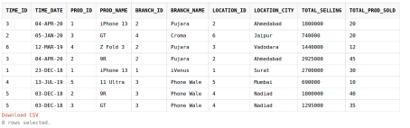

**4.5) Write down the queries to perform slice. In which one should keep one of the dimensions as constant and other dimensions should range from min to max.**

SELECT s.prod_id, MIN(s.prod_sold) as minimum_prod_sold, MAX(s.prod_sold) as

maximum_prod_sold

FROM sales s

GROUP BY s.prod_id;

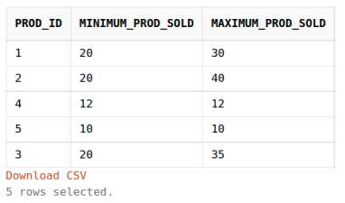

SELECT s.prod_id, MIN(s.prod_sold*s.prod_price) as minimum_total_sold, MAX(s.prod_sold*s.prod_price) as maximum_total_sold FROM sales s

GROUP BY s.prod_id;

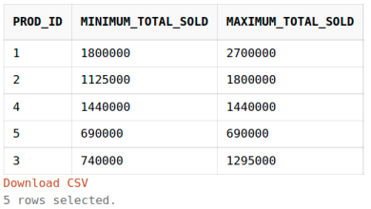

**4.6) Write down the queries to perform the dice. In which one has to keep two of the dimension’s constant**.

SELECT s.prod_id, b.branch_name, SUM(s.prod_sold*s.prod_price) as total_dollars_sold_at_NYC_store

FROM sales s, branch b

WHERE s.branch_id = b.branch_id and b.branch_name = 'Pujara' GROUP BY s.prod_id, b.branch_name;

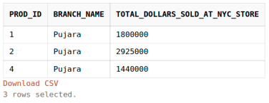

**4.7) Write down the queries to perform roll-up by keeping one dimension constant and others should range from min to max. It is more like a generalization.**

SELECT prod_id, MIN(prod_sold) AS minimum_prods_sold, MIN(prod_sold*prod_price)

AS minimum_sold, MAX(prod_sold) AS maximum_prods_sold, MAX(prod_sold*prod_price) AS maximum_sold

FROM sales

GROUP BY ROLLUP(prod_id)

ORDER BY prod_id

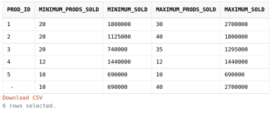

SELECT c.prod_name, SUM(s.prod_sold) as total_prods_sold FROM sales s, product c

WHERE s.prod_id = c.prod_id

GROUP BY ROLLUP(c.prod_name)

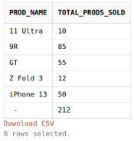

**4.8) Write down the queries to perform roll-up by keeping one dimension constant and others should range from min to max. It is more like a specialization Screen**

SELECT c.prod_name, SUM(s.prod_sold) as total_prods_sold FROM sales s, product c

WHERE s.prod_id = c.prod_id

GROUP BY c.prod_name